MACH4METAL

metalworking machinery

Transito 21, 6909 DA Babberich, Netherlands
Tel. + 31 (0)316 – 247123
Fax. + 31 (0)316 - 247956
info@mach4metal.com
www.mach4metal.com
Bank No : 66.52.13.883
IBAN : NL33 INGB 0665 2138 83
BIC : INGBNL2A
VAT : NL 815393635B01

Portable radial Drill MAS VOM 50
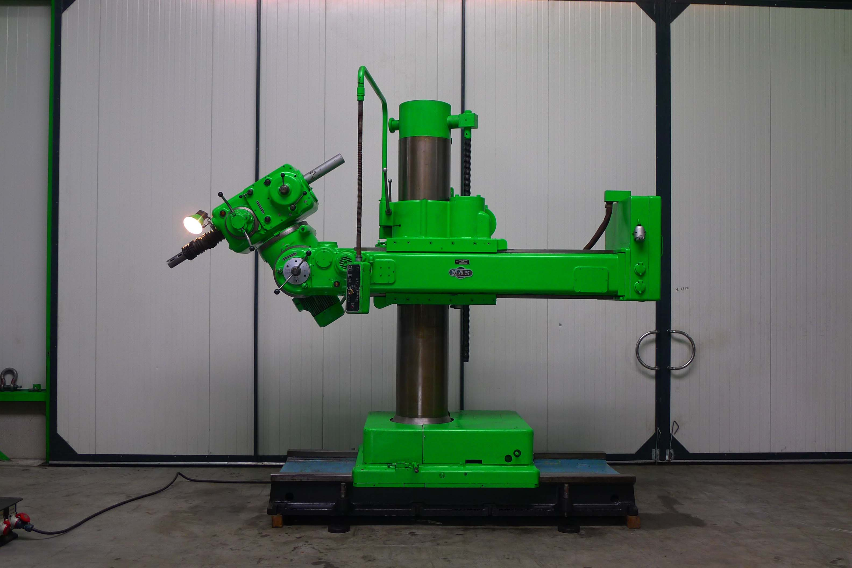
- Make : MAS – Kovosvit - CZ
- Typ : VRM 50
- Age : 70 er

- Max. drill Ø. 50 mm
- Max. Tap Ø. M 48

- Dist. spil – column. 2.070/1.170
- Dist. spil – table. 1.550/305
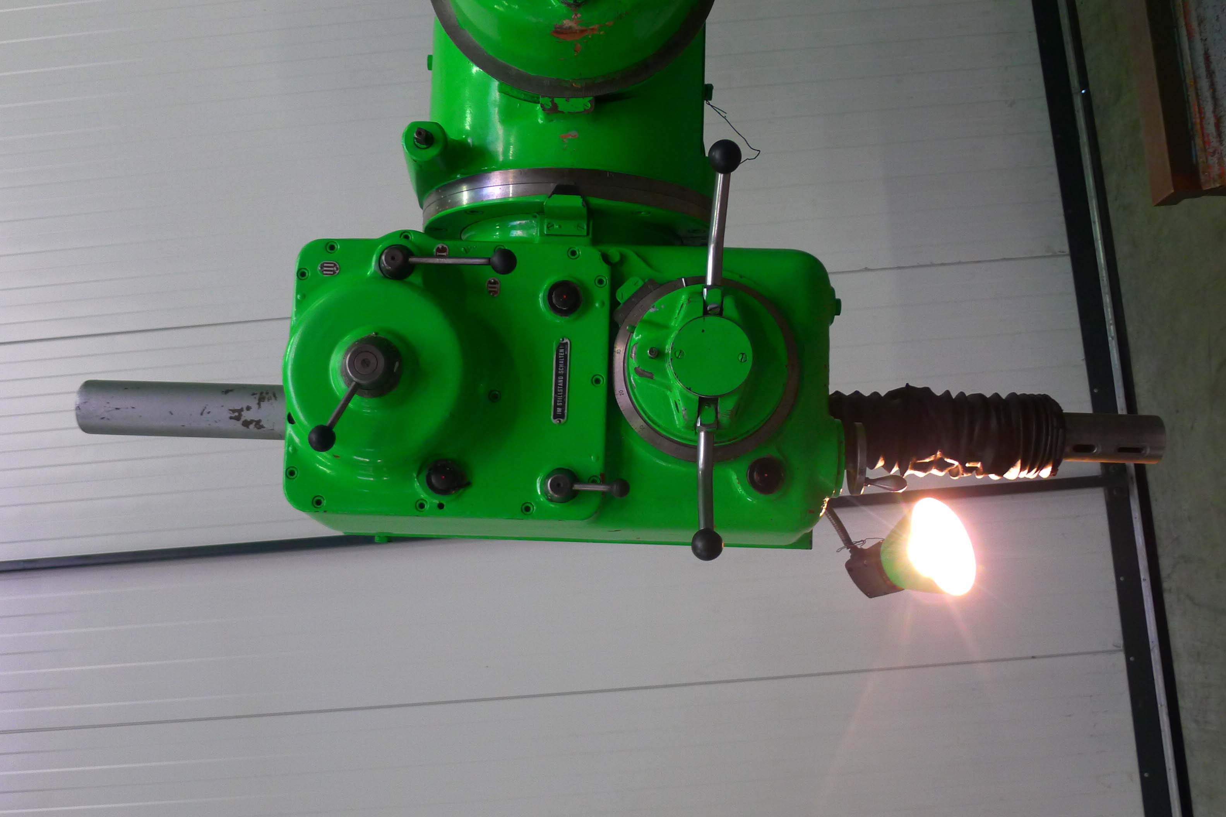
- Height adj. Arm on column. 1.250
- Hor. Adj. arm. 900

- Turn angle spilkop. 360°
- Spil konus. Mk – 5
- Adj. spilhuls. 350

- Speeds. 15 x 16 – 800 Rpm.
- Feeds. 6 x 0,05 – 0,5
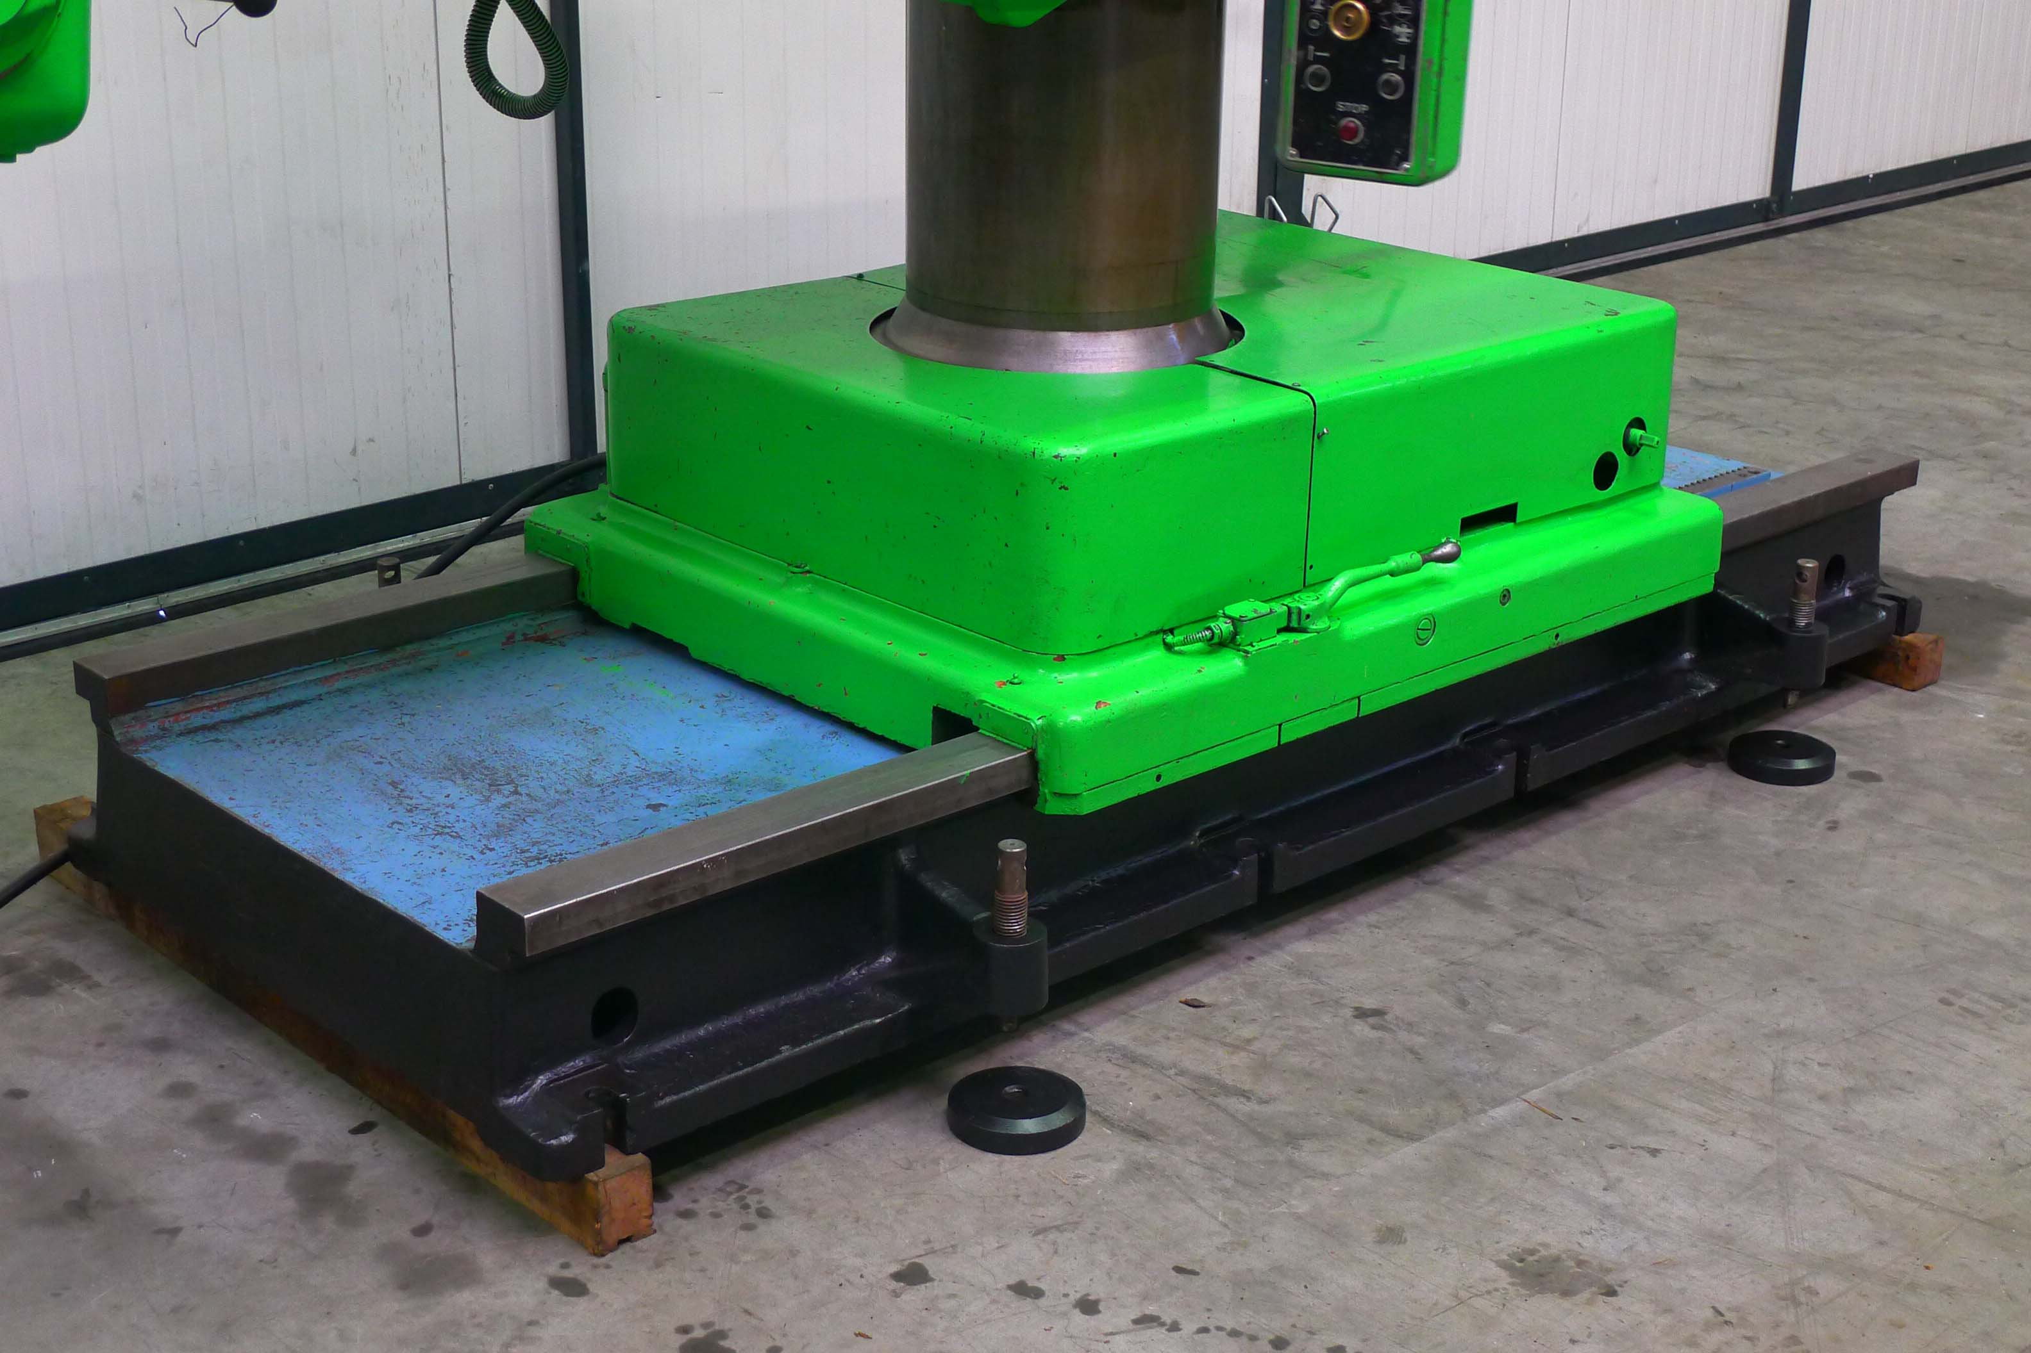
- Dim. Vloer opp. 3,74 x 4,54 x 3,4 mtr.
- Weight. Ca. 6.570 kg

Please Note: The above information has been obtained to the best of our ability and belief from, and from the manufacturers where possible. It is given in good faith, but its accuracy can not be guaranteed. Accordingly, it will not form a representation or constitute contractual terms. We advise you to check any vital details!

